Points of detail for BERLIOZ Grande Messe des Morts
JOINT HERTS CHOIRS 4th NOVEMBER 2007 Royal Albert Hall

[text in blue was added on 26th September 2007]

This document is to note additional points of interpretation – including dynamics, additional rests, etc. They include issues that became evident in the Regional rehearsals in September; particularly “NOTE” “IMPORTANT” points.

GENERAL POINTS :

The basic intention is to do what is in the Bärenreiter score. These notes are therefore changes / clarifications of what is in the score.
IMPORTANT: to make last notes of phrases accurate in length
IMPORTANT: to make dynamics effective especially graded diminuendos
IMPORTANT: to watch the beat; there is often no help with the beat/rhythms in the accompaniment; nor any help with pitching since the accompaniment is sparse or in unison;

ROUTE MAPs, points of clarification :

Where the direction is put in the middle of the two columns it applies to both parts. E.g. Sopranos at bar 79 in Lacrimosa (page 66); the list says "Sop 2" in the middle and therefore applies to both Sop 1 & 2. The reason for specifiying 2 is to acknowledge that the score suggests it is just Sop 2 ("II").
If a box is blank, then whatever that part was doing before continues; it does not mean "tacet"!

1. REQUIEM & KYRIE (page 3)

Bar
BeginningSTAND | as conductor comes on stage
beginning | 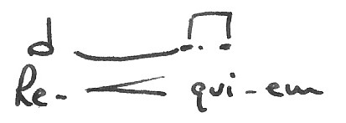  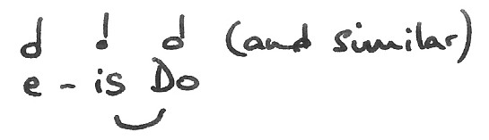
49 etc | Note sf and diminuendo (especially suddenly divided tenors)
54 | no cresc on beats 2 & 3 (i.e. after the paused 1st beat)
59 onwards | “dona eis” – clear vowels; rests are important
77 | poco rall
 | from this point, the music at the end of the Agnus is the same as here and therefore the same notes apply. Bar numbers in brackets [..] refer to the equivalent bar in the Agnus.
91 [92] | T – exaudi  exaudi
95 [96] | B - … ditto ………
116 [117] | “defunctis” – clear vowels and strong consonants
148 [149] onwards | “et lux perpetua” – strong consonants
160 165 | Note diminuendo
163 | B – “-is luceat” clear “s” and “l”
169 | 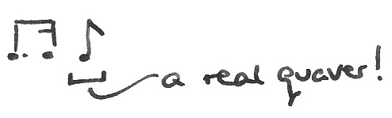  very precise whispered "luceat"
171 | 1st beat is  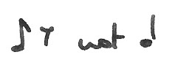  2nd beat will be late / “placed”
172 | Kyrie / eleison
174 onwards | christe / eleison
176 181 | only 3rd beat given for “Kyrie…”
197 | TURN THE PAGE immediately after finishing last phrase

2. DIES IRAE (page 18)

Bar
27 | Tenor – last note is A (accompaniment is wrong)
general | observe commas in the text but don’t add any more!
47 | Tenor - last note is G (accompaniment is wrong)
48 | comma at end of bar
52 | 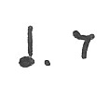  last note is
53 etc | Note that dynamics are different in different parts e.g. bar 53 pp & mf
56 | comma at end of bar
109 | Basses - last note is
125 | last note is
137 | diminuendo to p in 138
187 | Bass – sense of crescendo on 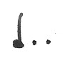notes; begins subito ff after pp section
215  217 | T & B – last note is
224/5 | 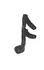  “x” on (may be easier to cross it out)
232 | S & T – insert quaver rest on last (triplet) quaver
233/4 | “-rs” on tied quaver
246 | top line is E flat (not natural as in accompaniment)
END - SIT | Sops, Altos, & Basses ON SIGNAL

3. Quid sum miser (page 39)

Bar
20/21 | “vix” not “vir”
42 onwards | Note crescendo and accelerando (and breaths)
43 | “-clinis cor”
45 | “cinis gere”
47 | Basses sing sitting

4. Rex Tremendae (page 41)

Bar
STAND | Sops, Altos, & Basses ON SIGNAL
2 & 4 | NOTE : quaver rest at end of bar – IMPORTANT!
6 | strong crescendo
10-11 | piu mosso
11 etc | 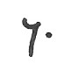  observe rest NOTE – IMPORTANT!
25-42 | WATCH! – there is a continuing accelerando; don’t get left behind!!
41 | Bass underlay should be “vi-ae” not “di-e”
43 & 47 | last beat is NOTE: IMPORTANT!
56 | first beat is  NOTE: IMPORTANT and accents also!
58 | meno mosso
64 | tempo
65 onwards | “de / or-” two clear syllables
73 | meno mosso
85 onwards | lean on the beginning of "salva me" then diminuendo
88/89 | 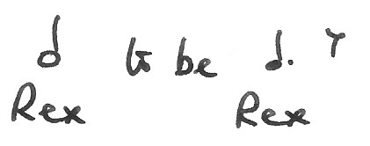 NOTE : – IMPORTANT!
91 | 2nd beat (“-tis”) is
END - SIT | ALL CHOIR ON SIGNAL for max 2 minutes

5. Quaerens me (page 52)

Bar
Beginning STAND | ALL ON SIGNAL
general | keeping the pitch is likely to be the main problem!
1 | pronunciation: “Quae…” sounds like “where” with a “qu” at the beginning.
31 | Tenor 2 (Tutti) – solid mp start  This is a very important lead … PLEASE!
31 | “in- je - mis – sco” (i.e. soft “g”)
40 | B1 – two “s”s : -us sup-
42 | B1 – first beat  B – clear vowels and strong consonants (“preces …”)
49 | A & T - clear vowels and strong consonants (“redemisti”)
53 | S – “la-bor tan-tus”
53/58 | B - clear vowels and strong consonants
58 | B1 – first beat
64 | T - clear vowels and strong consonants (“inter oves..”)
69 | rallentando up to the pause

6. Lacrimosa (page 57)

Bar
13 24 35 101 112 123 174 | second quaver accents need to be clear including shortening the note before
25 | B – penultimate note is A not G
58 etc 65 etc | on the beginning of "lacrimosa" (58 etc), "dies" (65 etc), etc then diminuendo
74 | 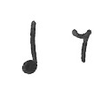  A & T – 1st note
81 | Sopranos : duple time quavers
126 etc | Tenors - lean on each beat (as marked by accents) but keep them joined
172/3 | “lacrimosa / lacrimosa / lacrimosa / dies” – no elisions
179 | “-la” is
180 | “-us” is
182 | 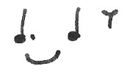  “-es” is
186 | “-es” is (in duple time from accompaniment)
188 | “-la” is (in duple time from accompaniment)
END – SIT | ON SIGNAL. NOTE: The Appeal follows so don’t move!

INTERVAL

7. OFFERTOIRE (page 83)
Bar
STAND | as Conductor comes on stage
6 onwards | each phrase from memory (not many syllables in any of them!). This worked well in the July Workshops with me giving a visual indication in rhythm of going up(!) to the B flat.
107 | 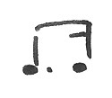  a new rhythm! -
138 | NOTE : a new note! - B natural and dotted rhythm after 7 beats - IMPORTANT
148 | comma at the end of the bar
SIT | Sops and Altos ON SIGNAL

8. HOSTIAS (page 97)

Bar
general | A to learn all of T1 part, please, though probably not to sing it all (I’m waiting until the full rehearsal to see how it sounds).
Altos | sing sitting
SIT | Tenors & Basses ON SIGNAL

9. SANCTUS (page 99)
Bar
STAND | Sops and Altos ON SIGNAL
46 STAND | Tenors & Basses immediately as “Hosanna” begins
“Hosanna” sections beginning at 46  and 139 : | All commas in the text are to be observed except where there are running quavers (e.g. Sop bar 57 & 190, Tenor bar 67 & 78) when it is not really practical.  However there is a comma MISSING in Sop bar 90 : “-sis, ho- ”
134 | division in Sop 2 : top note by Hertford, Bishop's Stortford and North Herts Guild; lower note by all other choirs.
198 | BEWARE the double time trap …..
199 | Comma before last “Hosanna”
SIT | Sops and Altos ON SIGNAL

10. AGNUS DEI (page 115)

Bar
opening | see notes in Hostias (number 8)
84 | see 1. REQUIEM – the notes there (from bar 83) are the same as apply here.
99 STAND | Sops and Altos on first beat of the bar
161 166 170 | NOTE: diminuendos & precision
185 | CLOSE BOOK AND SING “Amens” FROM MEMORY TO THE END

